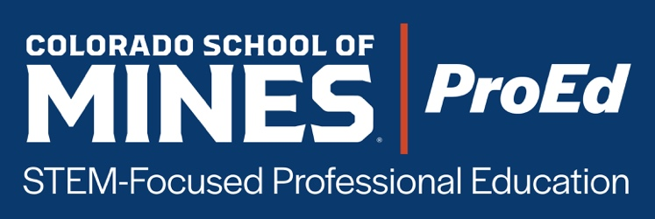
SWIPE FILE
Updated Jan 2026

GENERAL

Alumni discount code form
https://mailchi.mp/mines/gtowt1f82q

Discount code
ALUMNI10

ProEd catalog link
https://proed.mines.edu/pages/catalog-featured-courses

ProEd homepage
https://proed.mines.edu/

About ProEd
Mines ProEd delivers flexible, professional education options from Colorado School of Mines. Our courses translate cutting-edge technical expertise into real-world business impact.

- Gain fluency in the science and economics driving energy and resource industries
- Learn directly from experts shaping today’s technologies
- Build credibility with engineers, investors, and clients
- Discover opportunities for innovation, sustainability, and growth
- Step into new responsibility, accelerate advancement, or career pivot with new technical expertise

—

Of the many things that differentiate Colorado School of Mines from other universities, is our long history of preparing industry-ready graduates that go on to successful careers and industry leadership roles. That hasn't happened by accident. It reflects the strong partnerships that we have with industry and our commitment to aligning our education with industry needs.

That’s why we’re pleased to offer Mines ProEd, our professional education platform designed specifically to meet the evolving needs of the workforce and industry.

Whether you’re looking to sharpen your technical skills, expand your leadership capacity, or pivot to a new career path, Mines ProEd offers flexible learning formats—from self-paced online modules to in-person sessions—so you can learn in the way that works best for you.

—

QUICK LINES

If you’re ready to step into new responsibility, accelerate your advancement, or broaden your technical expertise, Mines ProEd offers flexible courses designed to help you grow and on your schedule.
–

Your career doesn’t stand still. Neither should your skills. That’s why we created Mines ProEd: online, hybrid, and in-person courses to help you stay ahead, sharpen your skills, and continue growing in your career.
–

Mines ProEd courses translate cutting-edge technical expertise into real-world business impact.
–

Mines ProEd, our professional education platform, is designed specifically to meet the evolving needs of the workforce and industry.
–

It’s time to redirect your career. Let’s turn “What if?” into “What’s next!” with Mines ProEd.
–

EMAIL

Newsletter content

In a mining industry transformed by rising demand, shrinking resources, community expectations, and unprecedented “above-ground” risks, professionals need more than technical skill—they need the ability to navigate complexity. That’s where Mines ProEd expert courses help you get ahead.

Dedicated Email 1 (Intro to ProEd)

Mines Expertise. Your Next Step Starts Here.
Your career doesn’t stand still. Neither should your skills. Technology, innovation, and global challenges are reshaping industries. To thrive, professionals need to keep learning, growing, and adapting.

That’s why Colorado School of Mines created Mines ProEd: online, hybrid, and in-person courses to help you stay ahead, sharpen your skills, and continue growing in your career.

From mining and sustainability to robotics, data science, leadership, and workplace skills, Mines ProEd courses are designed for working professionals who want to:
- Gain practical knowledge they can apply immediately
- Learn from Mines’ world-class faculty and industry experts
- Fit education into their busy schedules

If you’re ready to invest in your career and future, Mines ProEd is here to guide the way with courses that help you stay ahead in today’s fast-evolving landscape.

—

Dedicated Email 2 (Career… what’s next?)

You’ve worked hard for every step in your career so far with projects delivered, hours logged, problems solved. But maybe lately you’ve caught yourself wondering: “What’s next?”

When promotions slow, new challenges fade, and the salary stays the same, it’s easy to feel like you’re running in place. But you don’t have to accept that.

At Mines ProEd, we’re built for professionals exactly where you are: skilled, ambitious, but ready for the next chapter. We help you upgrade your credentials, sharpen your competitive edge, and recapture momentum.

Why it makes a difference:
- Courses designed for STEM professionals: you won’t get fluff, you’ll get relevant tools and insights.
- Flexible-by-design: access when you want it, learn at your pace without quitting your job to go back to school.
- Show up in your next review or promotion conversation with confidence and evidence you’ve invested in your future.

It’s time to redirect your career. Let’s turn “What if?” into “What’s next.”

Thank you for investing in your future,
Mines ProEd Team

Form to become a Subject Matter Expert:
https://webforms.pipedrive.com/f/clTeQxDh43DxZluuQxlgduRDzDnztn2vjizguzjcyzcHtmzZhocEMbCATC0qF1KMzV

